SOURCE CODE

print("****BANK TRANSACTION****")

#creating database

import mysql.connector

mydb=mysql.connector.connect (host="localhost",user="root", passwd="root")

mycursor=mydb.cursor()

mycursor.execute("create database if not exists bank")

mycursor.execute("use bank")

#creating required tables

mycursor.execute("create table if not exists bank_master(acno char(4) primary key,name varchar(30),city char(20),mobileno char(10),balance int(6))")

mycursor.execute("create table if not exists banktrans(acno char (4),amount int(6),dot date,ttype char(1),foreign key (acno) references bank_master(acno))")

mydb.commit()

while(True):

print("1=Create account")

print("2=Deposit money")

print("3=Withdraw money")

print("4=Display account")

print("5=Exit")

ch=int(input("Enter your choice:"))

#PROCEDURE FOR CREATING A NEW ACCOUNT OF THE APPLICANT

if(ch==1):

print("All information prompted are mandatory to be filled")

acno=str(input("Enter account number:"))

name=input("Enter name(limit 35 characters):")

city=str(input("Enter city name:"))

mn=str(input("Enter mobile no.:"))

balance=0

mycursor.execute("insert into bank_master values('"+acno+"','"+name+"','"+city+"','"+mn+"','"+str(balance)+"')")

mydb.commit()

print("Account is successfully created!!!")

#PROCEDURE FOR UPDATIONG DETAILS AFTER THE DEPOSITION OF MONEY BY THE APPLICANT

elif(ch==2):

acno=str(input("Enter account number:"))

dp=int(input("Enter amount to be deposited:"))

dot=str(input("Enter date of Transaction: YYYY-MM-DD "))

ttype="d"

mycursor.execute("insert into banktrans values('"+acno+"','"+str(dp)+"','"+dot+"','"+ttype+"')")

mycursor.execute("update bank_master set balance=balance+'"+str(dp)+"' where acno='"+acno+"'")

mydb.commit()

print("money has been deposited successully!!!")

#PROCEDURE FOR UPDATING THE DETAILS OF ACCOUNT AFTER THE WITHDRAWL OF MONEY BY THE APPLICANT

elif(ch==3):

acno=str(input("Enter account number:"))

wd=int(input("Enter amount to be withdrawn:"))

dot=str(input("enter date of transaction: YYYY-MM-DD "))

ttype="w"

mycursor.execute("insert into banktrans values('"+acno+"','"+str(wd)+"','"+dot+"','"+ttype+"')")

mycursor.execute("update bank_master set balance=balance-'"+str(wd)+"' where acno='"+acno+"'")

mydb.commit()

#PROCEDURE FOR DISPLAYING THE ACCOUNT OF THE ACCOUNT HOLDER AFTER HE/SHE ENTERS HIS/HER ACCOUNT NUMBER

elif(ch==4):

acno=str(input("Enter account number:"))

mycursor.execute("select * from bank_master where acno='"+acno+"'")

for i in mycursor:

print(i)

else:

break

OUTPUT

1.CREATE ACCOUNT

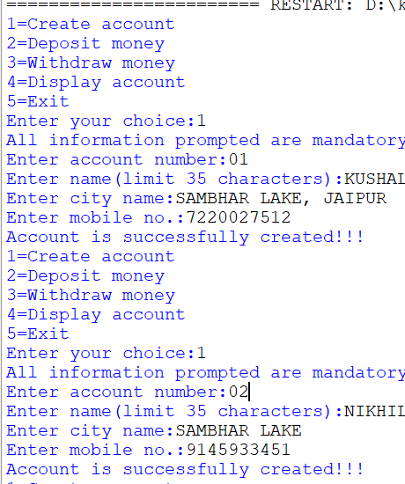

2.DEPOSIT MONEY

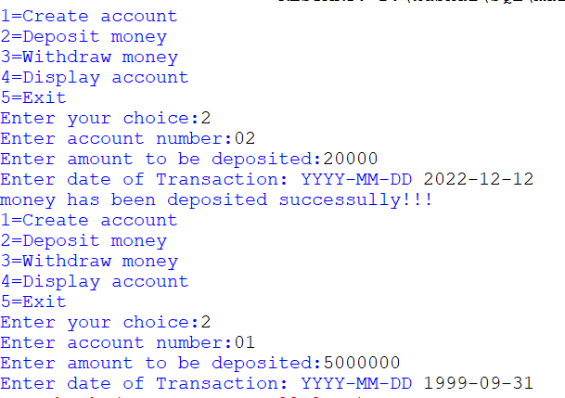

3.WITHDRAW MONEY

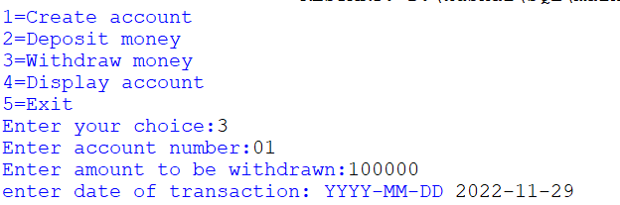

4.DISPLAY ACCOUNT

